**PROFESSIONAL READINESS FOR INNOVATION, EMPLOYABILITY**

**AND ENTREPRENEURSHIP PROJECT**

**REPORT** - WEEK 8

**Project Tile**: AI-powered Nutrition Analyzer for Fitness Enthusiasts

**Team ID:** PNT2022TMID15800

**GitHub ID**: Ibm-project-53441-1665376120

We had the training sessions on oct 13 and oct 15 of the year 2022. We attended the training sessions and completed our assignment 4 which was given on 15 th of october month. We were also given the quiz assessment on 15 th of october. The training sessions had the following content.

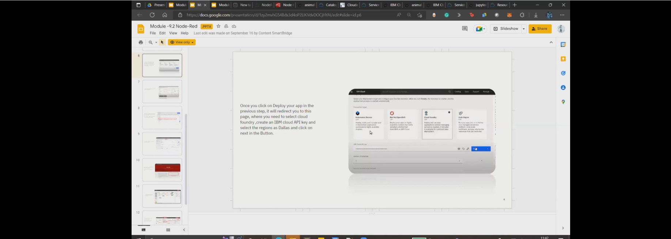

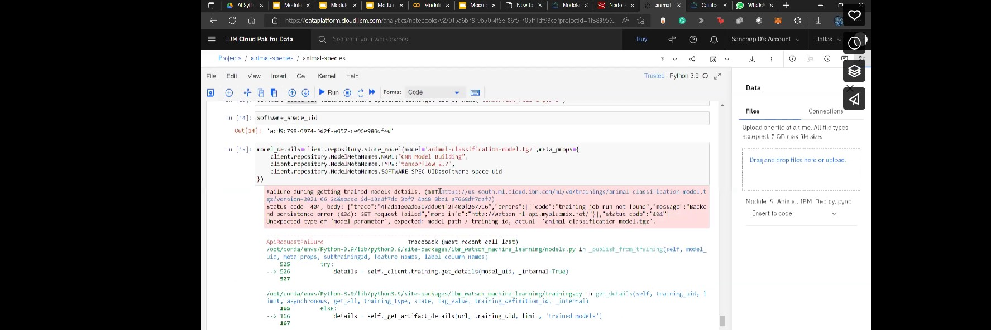

This week we were assigned the work of

1. Customer journey map

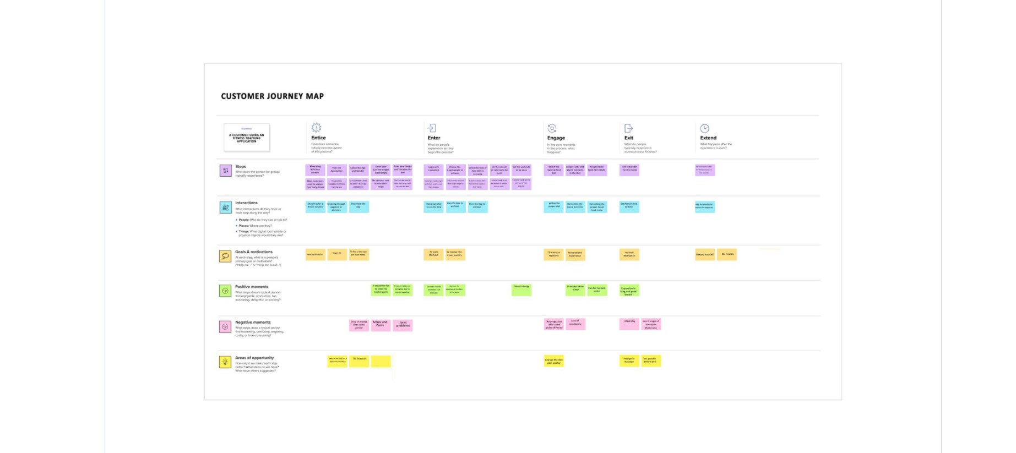

1. Functional requirements

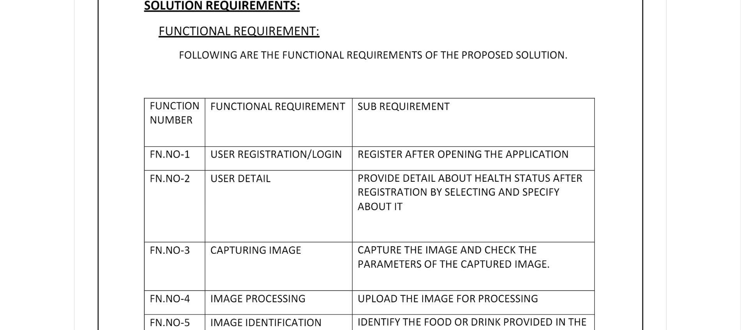

1. Data flow diagram

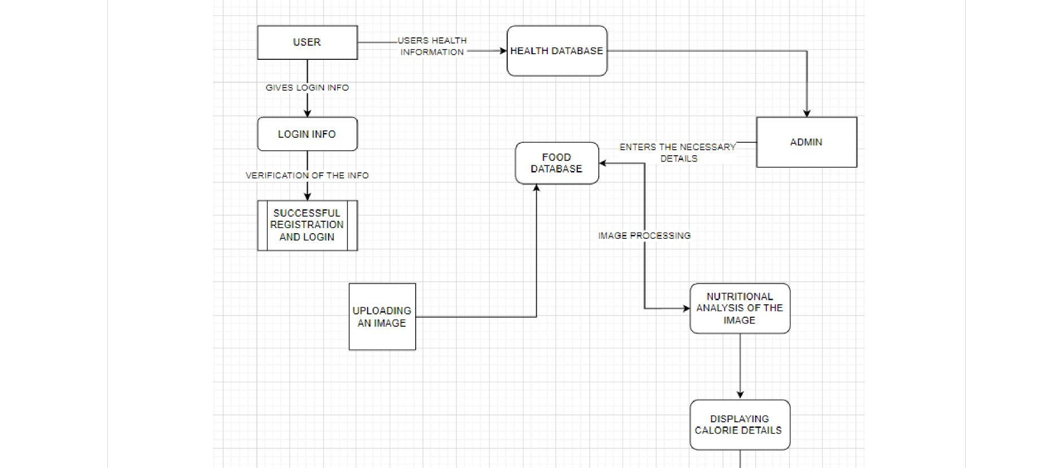

1. Technical architecture